**MuvTime**

metin, noel ağacı, noel içeren bir resim

Açıklama otomatik olarak oluşturuldu

**Computer Engineering**

**Senior Project Report**

**Advisor: Associate Proffesor Tuğba Önal SÜZEK**

**Erkin Alkan**

**Date:** 03/07/2025

MuvTime: AI-Powered Fitness Tracking Application with Real-Time Exercise Form Analysis

Erkin Alkan

Computer Engineering

Summary

In today’s world lack of movement is like inevitable. Especially for children who addicted to phones and tablets. Inviting new physical diseases to their bodies even they don’t know their names. One of the new problems of the world is technology addiction. We are here to make this addiction to turn our advantage. Trying to get children attention for making them little exercises through a mobile app.

Our project aims to make exercising more enjoyable for children by using artificial intelligence to monitor their simple movements in real-time, ensuring correct execution, and thus preventing potential injuries. While some educational and game applications exist to encourage children to be more active daily, most current applications either fail to capture children's interest or can be categorized as programs that don't effectively promote physical activity.

The benefit we aim to provide to society is to engage children daily through entertainment, consequently instilling sports habits in them, and minimizing future health issues. During my authorized visits to pediatric clinics in Muğla, I observed that, beyond patients with congenital physical and mental disabilities, there were also many patients whose conditions were primarily due to a lack of physical activity. After passing the necessary tests, the software will be published on Google Play Store.

The app is build by Android Studio and VS code. The base of the app is Java/Kotlin and backend is .Net deployed on Azure. Database is supabase with Postgre SQL and deployed aswell. I used Yolov8 pose detection for image processing.

**Table of Contents**

**1. Introduction4**

**2. Methods4**

**2.1 Image Processing**………………………………………………………………………**4**

**2.2 Creating User Interface**………………………………………………………..………**4**

**2.3 Backend**………………………………………………………………………………….**5**

**2.4 Database**…………………………………………………………………………………**5**

**2.5 Gamificition**……………………………………………………………………………...**6**

**3. Conclusion6**

**4. References7**

1. **Introduction**

Our first priority is making a UI user and child friendly, easy to use and easy to understand. Easy interface will help users to understand the exercises well and easy to navigate through screens. Second priority is calculations for detecting the pose and count the reps correctly using landmarks. Every landmark will process every second and give us their x,y coordinates. Third of all is a little competition for users giving them a leaderboard list and a friends list to see what their friends did and give them a urge to use the app and pass their friends point. This is going to be their motivation for doing more exercise.

I deployed the backend to Azure(Poland Center) using kudu cmd and database to supabase(West Germany) using sql for worldwide and fast connection.

Our goal is to help childeren in lack of motion. Give them a little boost to stand and make basic exercises in minutes and get some reward after doing basic exercises. To help them gain doing exercise habit. In the bigger picture, our project aims to help technology addicted children.

1. **Methods**

**2.1 Image Processing**

I processed using ultralytics library for yolov8 light model to a ONNX file using python.

model = YOLO("yolov8n-pose.pt")

model.export(*format*="onnx", *dynamic*=True)

Then this will export a onnx file



We will put this model inside Android studio for produce landmarks and keep trace of them.

**2.2 Creating User Interface**

We will develop a user-friendly interface using the Android studio with Java.

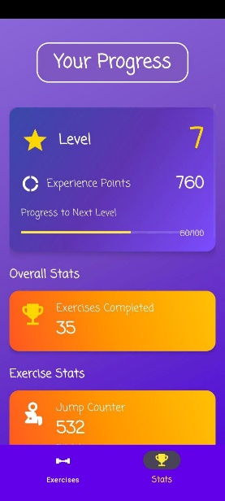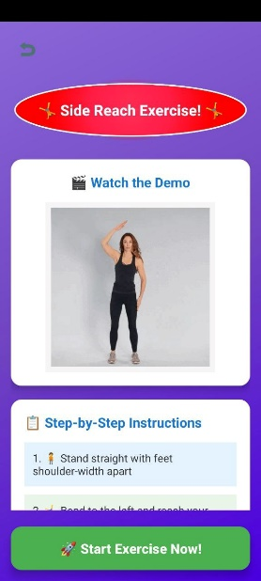

**2.3 Backend**

Our backend is .Net framework with C#, basic structure for handling API. After writing our model and controllers we will deploy our backend to Azure through kudu console, and after that our backend will be published online. We will give our database (Supabase) keys to azure to connect it.

**2.4 Database**

Our database has a basic structure too. We need only two tables that need a little storage, only saving the users emails, passwords(UUID), their exercise count,xp and levels. I selected supabase because it is free to use and meets my demands. Also can manipulate tables with SQL.

**2.5 Gamificition**

We plan to addict users to our app using reward system. Make them familiarize exercises and doing basic exercises in their daily life. To achive this we put a reward system in our app. When you complete exercise, you will be rewarded by experience points and move up in the global leaderboard. You will be able to add your friends in friends list and see what they achive and compete with them. This urge will push the users to do more exercises. But you can’t spam the one exercise fully. After doing a exercise it will be go in a cooldown, like when you do jumping exercise you have to wait five minutes to do again.

1. **Conclusion**

Working on the MuvTime project has been an exciting and rewarding journey. My goal was to make childeren get moving app, free and accessible, and I believe I have taken a big step in that direction. By combining artificial intelligence, computer vision, and mobile technology, I have created an app that not only counts exercise repetitions but also helps users improve their form, something that’s usually only possible with a personal trainer.

Throughout this project, we faced plenty of challenges, from getting real-time video analysis to work smoothly, to making sure the app was easy and enjoyable to use. Each obstacle taught us something new and pushed me to find creative solutions. Seeing the different parts of the system; Android app, backend API, and AI module come together was especially satisfying.

What excites me most is the potential impact of MuvTime. With this app, anyone can get meaningful feedback on their workouts, no matter where they are or what equipment they have. I hope this project inspires further innovation in digital health and helps more people stay active and healthy.

Looking foreward, there’s still so much I can do, like adding new exercises, connecting people to each other, or even building a community around the app. But for now, I’m proud of what I’ve accomplished and grateful for the opportunity to work on something that can make a real difference.

1. **References**

[1] Ultralytics YOLOv8 Documentation. https://docs.ultralytics.com/

[2] Android Developers. “Android Studio User Guide.” https://developer.android.com/studio

[3] Microsoft. “.NET Documentation.”

https://learn.microsoft.com/en-us/dotnet/

[4] Supabase Documentation.

https://supabase.com/docs

[5] PostgreSQL Documentation.

https://www.postgresql.org/docs/

[6] ONNX: Open Neural Network Exchange.

https://onnx.ai/

[7] Azure App Service Documentation.

https://learn.microsoft.com/en-us/azure/app-service/

[8] OpenCV Documentation.

https://docs.opencv.org/

[9] Google Material Design Guidelines. https://material.io/design/